

Lab – Configuring EtherChannel

**Topology**

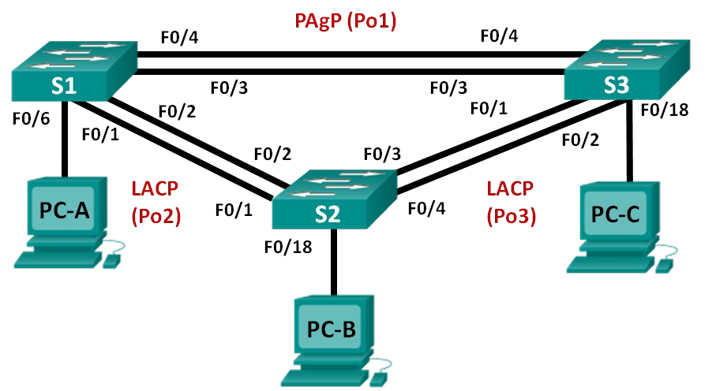

G1/0/5

G1/0/5

S3

G1/0/7

G1/0/6

G1/0/2

G1/0/6 G1/0/4

G1/0/3

S4

G**F**1**0**/**/**0**2**/2**4**4

G1/0/1

F0/2

F0/4

F0/1

S1

F0/3

Ethernet PC

VAN PC

**Addressing Table**

|  |  |  |  |
| --- | --- | --- | --- |
| **Device** | **Interface** | **IP Address** | **Subnet Mask** |
| S1 | VLAN 99 | 192.168.99.11 | 255.255.255.0 |
| S3 | VLAN 99 | 192.168.99.13 | 255.255.255.0 |
| S4 | VLAN 99 | 192.168.99.14 | 255.255.255.0 |
| PC-A | NIC | 192.168.10.1 | 255.255.255.0 |
| PC-B | NIC | 192.168.10.2 | 255.255.255.0 |
| PC-C | NIC | 192.168.10.3 | 255.255.255.0 |

**VLAN Assignments**

|  |  |
| --- | --- |
| **VLAN** | **Name** |
| 10 | Staff |
| 99 | Management |

**Objectives**

**Part 1: Configure Basic Switch Settings Part 2: Configure PAgP**

**Part 3: Configure LACP**

**Background / Scenario**

Link aggregation allows the creation of logical links that are comprised of two or more physical links. This provides increased throughput beyond using only one physical link. Link aggregation also provides redundancy if one of the links fails.

In this lab, you will configure EtherChannel (a form of link aggregation used in switched networks) using both the Port Aggregation Protocol (PAgP) and the Link Aggregation Control Protocol (LACP).

**Note**: PAgP is a Cisco-proprietary protocol that you can only run on Cisco switches and on switches that are licensed vendors to support PAgP. LACP is a link aggregation protocol that is defined by IEEE 802.3ad, and it is not associated with any specific vendor.

LACP allows Cisco switches to manage Ethernet channels between switches that conform to the 802.3ad protocol. You can configure up to 16 ports to form a channel. Eight of the ports are in active mode and the other eight are in standby mode. When any of the active ports fail, a standby port becomes active. Standby mode works only for LACP, not for PAgP.

**Note**: Make sure that the switches have been erased and have no startup configurations. If you are unsure, contact your instructor.

**Required Resources**

* 3 Switches
* 3 Virtual PCs (if on-campus)
* Ethernet cables as shown in the topology

# Part 1: Configure Basic Switch Settings

In Part 1, you will set up the network topology and configure basic settings, such as the interface IP addresses, device access, and passwords.

## Step 1: Initialize and reload the switches. Step 2: Validate the network topology.

Validate network devices are interconnected as shown in the topology diagram and cabled as necessary.

PCs are included in the topology diagram for your reference only. PCs will not be available when working online.

## Step 3: Initialize and reload the switches.

**Step 4: Configure basic settings for each switch.**

1. Disable DNS lookup.

1. Configure the device name as displayed in the topology.
2. A black text on a white background

   AI-generated content may be incorrect.A black text on a white background

   AI-generated content may be incorrect.Create a MOTD banner warning users that unauthorized access is prohibited.

1. Configure **logging synchronous** to prevent console message from interrupting command entry.



1. 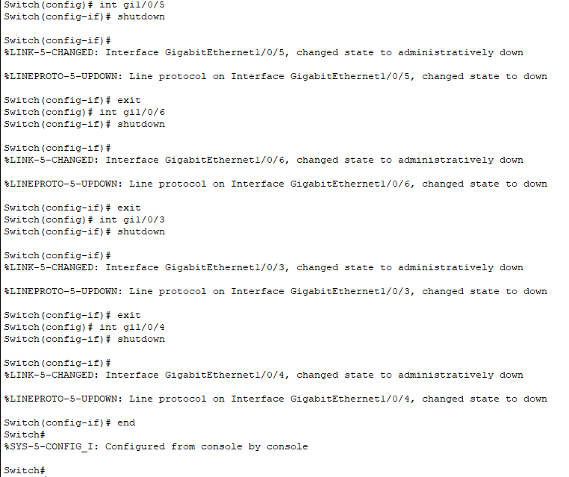Shut down all switch ports except the ports connected to PCs.

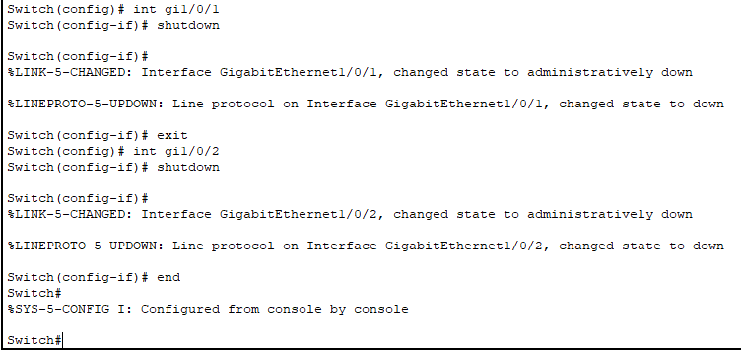

1. Configure VLAN numbers and names as per the configuration table

1. Configure the switch ports with attached hosts as access ports in the **Staff** VLAN.

1. Assign the IP addresses according to the Addressing Table.

## Step 5: (on-campus tasks) Configure the PCs.

Assign IP addresses to the PCs according to the Addressing Table.

You may configure PC-B as a second Ethernet Virtual PC if you have access to another computer near you.

# Part 2: Configure PAgP

PAgP is a Cisco proprietary protocol for link aggregation. In Part 2, a link between S3 and S4 will be configured using PAgP.

## Step 1: Configure PAgP on S3 and S4.

For a link between S3 and S4, configure the ports on S3 with PAgP desirable mode and the ports on S4 with PAgP auto mode. Enable the ports after PAgP modes have been configured.

S3(config)# **interface range g1/0/5-6**

S3(config-if-range)# **channel-group 1 mode desirable**

Creating a port-channel interface Port-channel 1

S3(config-if-range)# **no shutdown**

S4(config)# **interface range g1/0/5-6** S4(config-if-range)# **channel-group 1 mode auto** Creating a port-channel interface Port-channel 1

S4(config-if-range)# **no shutdown**

*Mar 1 00:09:12.792: %LINK-3-UPDOWN: Interface GigabitEthernet0/5, changed state to up

*Mar 1 00:09:12.792: %LINK-3-UPDOWN: Interface GigabitEthernet0/6, changed state to up

S4(config-if-range)#

*Mar 1 00:09:15.384: %LINEPROTO-5-UPDOWN: Line protocol on Interface GigabitEthernet0/5, changed state to up

*Mar 1 00:09:16.265: %LINEPROTO-5-UPDOWN: Line protocol on Interface GigabitEthernet0/6, changed state to up

S4(config-if-range)#

*Mar 1 00:09:16.357: %LINK-3-UPDOWN: Interface Port-channel1, changed state to up

*Mar 1 00:09:17.364: %LINEPROTO-5-UPDOWN: Line protocol on Interface Port-channel1, changed state to up

*Mar 1 00:09:44.383: %LINEPROTO-5-UPDOWN: Line protocol on Interface Vlan1, changed state to up

## Step 2: Examine the configuration on the ports.

Currently the G1/0/5, G1/0/6, and Po1 (Port-channel1) interfaces on both S3 and S4 are in access operational mode with the administrative mode in dynamic auto. Verify the configuration using the **show run interface** *interface-id* and **show interfaces** *interface-id* **switchport** commands, respectively. The example configuration outputs for G1/0/5 on S3 are as follows:

### S3# show run interface g1/0/5

Building configuration...

Current configuration : 103 bytes

!

interface GigabitEthernet1/0/5 channel-group 1 mode desirable

### S3# show interfaces g1/0/5 switchport

Name: Gi1/0/5 Switchport: Enabled

Administrative Mode: dynamic auto

Operational Mode: static access (member of bundle Po1) Administrative Trunking Encapsulation: dot1q Operational Trunking Encapsulation: native

Negotiation of Trunking: On Access Mode VLAN: 1 (default)

Trunking Native Mode VLAN: 1 (default) Administrative Native VLAN tagging: enabled Voice VLAN: none

Administrative private-vlan host-association: none Administrative private-vlan mapping: none Administrative private-vlan trunk native VLAN: none

Administrative private-vlan trunk Native VLAN tagging: enabled Administrative private-vlan trunk encapsulation: dot1q Administrative private-vlan trunk normal VLANs: none Administrative private-vlan trunk associations: none Administrative private-vlan trunk mappings: none

Operational private-vlan: none Trunking VLANs Enabled: ALL Pruning VLANs Enabled: 2-1001 Capture Mode Disabled

Capture VLANs Allowed: ALL

Protected: false

Unknown unicast blocked: disabled Unknown multicast blocked: disabled Appliance trust: none

## Step 3: Verify that the ports have been aggregated.

### S3# show etherchannel summary

Flags: D - down P - bundled in port-channel I - stand-alone s - suspended

H - Hot-standby (LACP only) R - Layer3 S - Layer2

U - in use f - failed to allocate aggregator

M - not in use, minimum links not met u - unsuitable for bundling

w - waiting to be aggregated d - default port

Number of channel-groups in use: 1 Number of aggregators: 1

Group Port-channel Protocol Ports

------+-------------+-----------+-----------------------------------------------

1 Po1(SU) PAgP Gi1/0/5(P) Gi1/0/6(P)

### S4# show etherchannel summary

Flags: D - down P - bundled in port-channel I - stand-alone s - suspended

H - Hot-standby (LACP only) R - Layer3 S - Layer2

U - in use f - failed to allocate aggregator

M - not in use, minimum links not met u - unsuitable for bundling

w - waiting to be aggregated d - default port

Number of channel-groups in use: 1 Number of aggregators: 1

Group Port-channel Protocol Ports

------+-------------+-----------+-----------------------------------------------

1 Po1(SU) PAgP Gi1/0/5(P) Gi1/0/6(P)

What do the flags, SU and P, indicate in the Ethernet summary?

* “P” in the Ethernet summary demonstrates “Priority” bit or flag. Additionally, in the EthernetChannel, priority mechanisms exist to give certain types of traffic preferential treatment.
* “S” could indicate that “Sent” and “U” can mean “Received”. This is a commom way to represent the direction of network traffic.

## Step 4: Configure trunk ports.

After the ports have been aggregated, commands applied at the port channel interface affect all the links that were bundled together. Manually configure the Po1 ports on S3 and S4 as trunk ports and assign them to native VLAN 99.

S3(config)# **interface port-channel 1**

S3(config-if)# **switchport mode trunk**

S3(config-if)# **switchport trunk native vlan 99**

S4(config)# **interface port-channel 1**

S4(config-if)# **switchport mode trunk**

S4(config-if)# **switchport trunk native vlan 99**

## Step 5: Verify that the ports are configured as trunk ports.

1. Issue the **show run interface** *interface-id* commands on S3 and S4. What commands are listed for G1/0/5 and G1/0/6 on both switches? Compare the results to the running configuration for the Po1 interface? Record your observation.

1. Issue the **show interfaces trunk** and **show spanning-tree** commands on S3 and S4. What trunk port is listed? What is the native VLAN? What is concluding result from the output?

=> The trunk port in the listed is Po1 and the native vlan is VLAN 99

=> The ports GigabitEthernet1/0/5 and GigabitEthernet1/0/6 are indicated as the Po1

From the **show spanning-tree** output, what is port cost and port priority for the aggregated link?

=> The port cost of Po1 is 3

=> The priority number of the aggregated link (Po1) is 128.29

LACP is an open source protocol for link aggregation developed by the IEEE. In Part 3, the link between S3 and S1, and the link between S1 and S4 will be configured using LACP. Also, the individual links will be configured as trunks before they are bundled together as EtherChannels.

## Step 1: Configure LACP between S3 and S1.

S3(config)# **interface range g1/0/1-2**

S3(config-if-range)# **switchport mode trunk**

S3(config-if-range)# **switchport trunk native vlan 99** S3(config-if-range)# **channel-group 2 mode active** Creating a port-channel interface Port-channel 2

S3(config-if-range)# **no shutdown**

S1(config)# **interface range f0/1-2**

S1(config-if-range)# **switchport mode trunk** S1(config-if-range)# **switchport trunk native vlan 99** S1(config-if-range)# **channel-group 2 mode passive** Creating a port-channel interface Port-channel 2

S1(config-if-range)# **no shutdown**

## Step 2: Verify that the ports have been aggregated.

What protocol is Po2 using for link aggregation? Which ports are aggregated to form Po2? Record the command used to verify.

* Protocols are used in Po2 for link aggregation include GigabitEthernet1/0/1 and GigabitEthernet1/0/2.
* Command line: “show etherchannel summary” on bith switches S3 and S1

**Step 3: Configure LACP between S1 and S4.**

1. Configure the link between S1 and S4 as Po3 and use LACP as the link aggregation protocol.

S1(config)# **interface range f0/3-4**

S1(config-if-range)# **switchport mode trunk** S1(config-if-range)# **switchport trunk native vlan 99** S1(config-if-range)# **channel-group 3 mode active** Creating a port-channel interface Port-channel 3 S1(config-if-range)# **no shutdown**

S4(config)# **interface range g1/0/3-4**

S4(config-if-range)# **switchport mode trunk** S4(config-if-range)# **switchport trunk native vlan 99** S4(config-if-range)# **channel-group 3 mode passive** Creating a port-channel interface Port-channel 3

S4(config-if-range)# **no shutdown**

1. Verify that the EtherChannel has formed.

## Step 4: Verify end-to-end connectivity.

Verify that all switches can ping each other. If not, troubleshoot.

Would PCs be able to ping each other? Yes? No? Why?

* PCs cannot ping each other because switches are in the VLAN 99 and PCs are in the VLAN 10, resulting in PCs cannot ping each other while all switches can ping each other

**Reflection**

What could prevent EtherChannels from forming?

* There are several issues could prever EtherChannels from forming include configuration mismatches, physical problems, protocol errors, interface limits, and STP blocking.